Ceremonial Bugle Software

This software allows you to modify the play lists of the Multi-call setting of the Digital Ceremonial Bugle Insert produced during 2006, using the USB cable provided.

Installation

Requirement
In order to perform this function, your computer should have the following specification(s):
- Operating system: Windows NT, 2000, me or XP
- USB port 1.1 and above
- 20MB free space

Installing the software
To install the software, follow the steps below:
- Click on Digital Ceremonial Bugle.zip file and double click on setup.exe.
- Follow the instructions of the install program. By default the software will be installed under: program files\digital ceremonial bugle.

Overview
The Ceremonial Bugle Insert produced in 2006 and beyond allows you to configure your own play-lists in the Multi-call setting.

MP3 Files
You can use your own MP3 files or downloads from the Ceremonial Bugle website (www.ceremonialbugle.com).
The MP3 files format should have the following specifications:
- CD quality (44.1kHz sampling frequency)
- Mono channel
- For optimal quality 80 or 64 kbps bit rate compression should be used.
Commercial software like CoolEdit, Goldwave or Windows Media player can transform audio files to MP3 files. The MP3 files should be saved under the same directory as the program.

User Interface
The interface has 2 sections. The right section is the list of calls within the insert and the left hand side is the list and order of the multi-call play-lists. Before you can reconfigure any of the play-lists, you need to connect the Ceremonial Bugle insert to your computer.

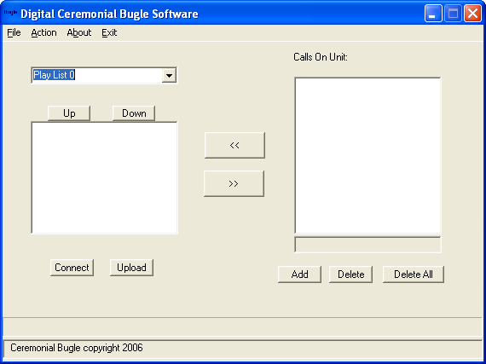

Connecting the unit

Connecting the unit
To connect the unit, remove the rubber washer from the unit. Beneath, you will find a small USB port. Connect the small end of the cable provided with to the Insert. Connect the other side of the cable to the USB port of your computer. Open the ceremonial bugle software. Switch ON the insert.

Disconnecting the Unit
To disconnect the unit, exit the Ceremonial Bugle Software. If you uploaded data to the unit, make sure the data transfer is finished before closing the interface or disconnecting the insert. If you disconnect the insert during a data transfer, it will not work properly.
Then switch the insert OFF and disconnect the USB cable.

First Connection

The configuration (profile) of the inserts calls and multi-play lists will appear in the software once you click the connect button. In the right hand box is the list of all the calls on the insert. On the left, is the list of the 10 different play-lists.

Before changing the data on the insert it is recommended that you backup the original profile from the insert to your computer. To do this this, click the connect button or go to menu Action->connect. Then go to File-save. Enter a name of the file for this data (we recommend to use default.dcb), and click OK.

You can now change any of the play-lists on the insert by creating a new profile. If you ever want to retrieve the original data profile, you simply have to load the default.dcb file again.

Creating a new profile

Adding/Deleting a file
To add a new call to the insert, click on the ADD button in the Ceremonial Bugle Software. Then select the directory where the program resides and select the desired MP3 files. The number of calls that can be put on the unit is limited to 20 or less if memory is full. The new calls will appear in the “Calls on Insert” box. When adding the files, the order in which you add the file is not important.

To delete a call, select it by clicking on it with the mouse and click the DELETE button. If the call is still used in some of the play-list a warning message will appear. If you click OK, the call will be deleted and removed from all the play-lists.

If you click DELETE ALL, all the calls on the insert will be removed (and all play-list will be emptied). The files will be saved into the unit, only after the upload operation.

Revising a play-list
After you add the call into the insert, you are ready to create your play-list.
First select the play-list that you want to create using the scroll down menu.
Then select the call you want to add into the play-list by clicking on it in the unit list and pressing the << button. You can add as many calls as you want on the play-list. The order, in which the files appear below the play-list, will be the order they will be played.

To move a call up or down the list use the up and down button.

To remove a call select it in the play-list window and click on the >> button.
Each play-list is limited to 16 files maximum.

Saving profile
Once you have finish creating your play-list, we recommend you save them by going to the File menu and click save. When prompted enter the name under which you want to save the profile.

It is safe to save your profile from time to time while you are creating your play-list.
You don’t need to create all your play-lists at the same time.

Each play list is limited to a total of 16 calls/files.

Uploading the data

After modifying the play-lists with your selections, you can upload them to the insert by clicking on Upload, or go to the menu Action-> upload.

The progress bar and status bar at the bottom of the window will inform you of the status.
When the status bar indicates Success, the data has been transferred and the unit is ready to be disconnected. It takes few minutes to upload the data.

If you have modified the profile, we recommend saving your profile at this time.
You should not close the software while the uploading process is taking place. If you try to close the program, and warning window will appear prompting you to finish the uploading of the file before attempting to close the program. Once the data transfer is finished (message success in status bar), exit the Ceremonial Bugle Software, switch OFF the unit and disconnect the cable.

At this point you are ready to use your Ceremonial Bugle Insert. Please reference the Ceremonial Bugle Insert manual on how to set and use the Multi-call mode.

